# Installing Oracle OLEDB / ODBC

Download the Oracle client software. Latest file is win64_11gR2_client.zip (600Mb download). Unzip to a temp folder.

In the Client folder, run the Setup.exe – on Windows 7 and 2008, Run as Administrator.

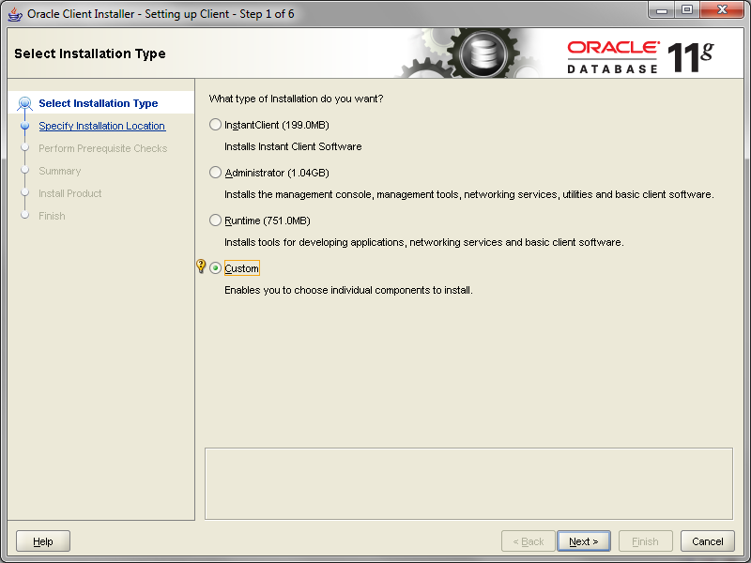

Select “Custom” for the installation type. Click “Next”.

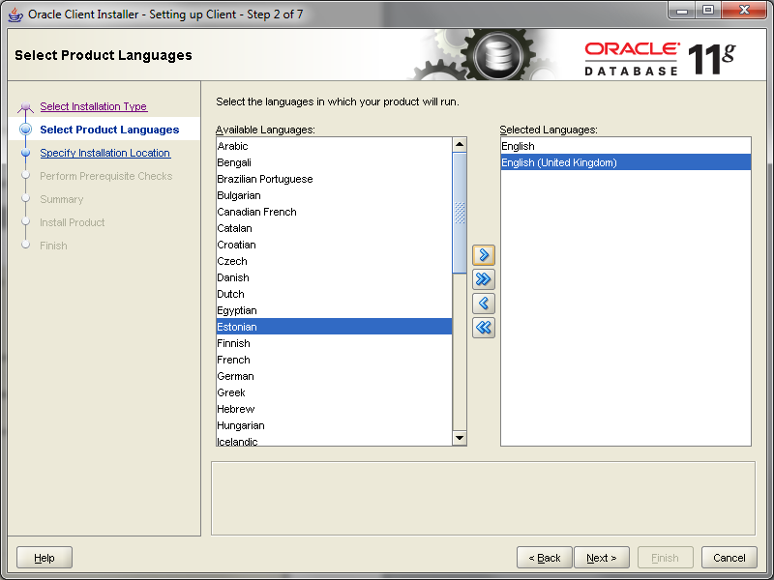

Select the correct language and click “Next”.

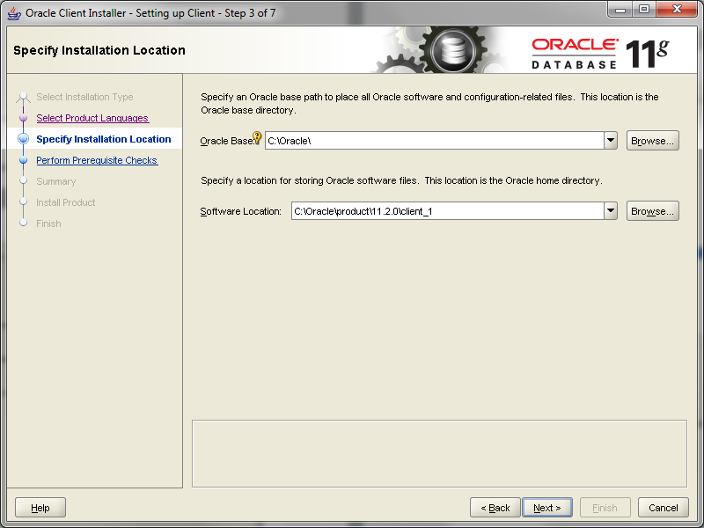

Set the right paths and click “Next”.

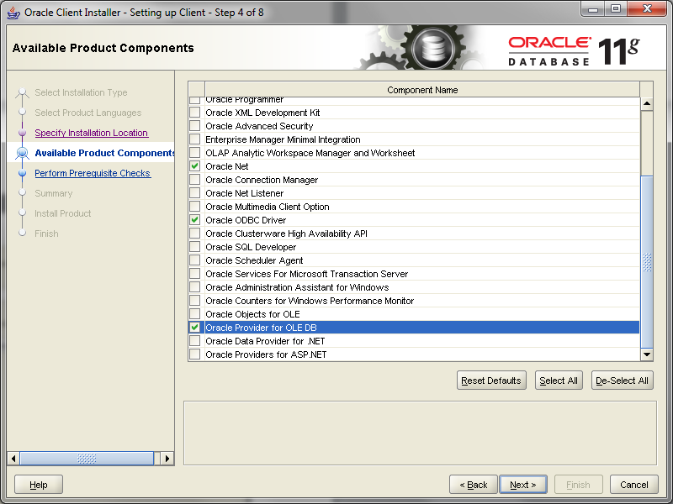

Select “Oracle Net”, “Oracle ODBC Driver” and “Oracle Provider for OLEDB” (Note: SQL*Plus can also be useful if you don’t have TOAD).

Click “Next”.

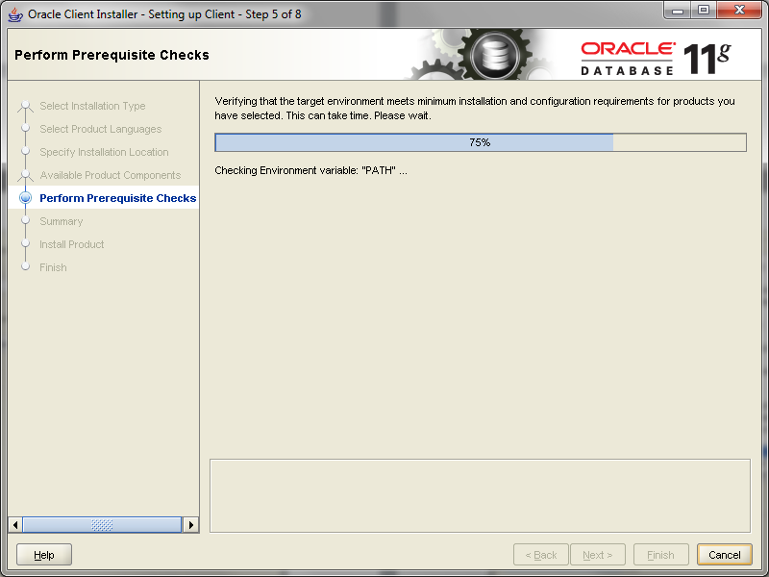

The installation checks settings.

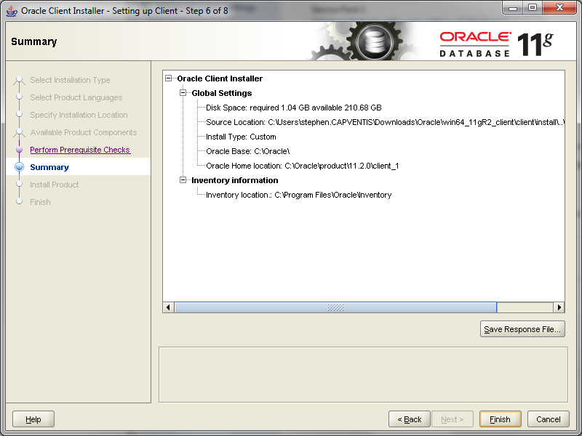

Confirm settings are OK and click “Finish”.

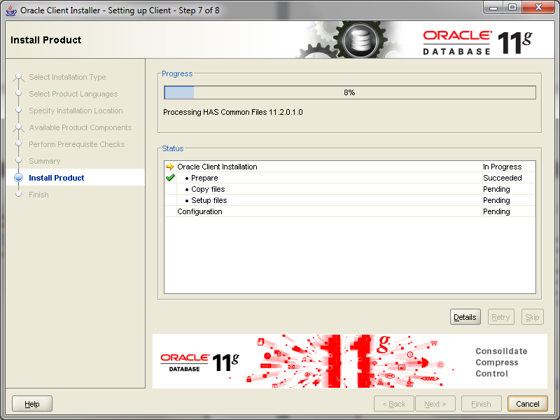

The installation continues.

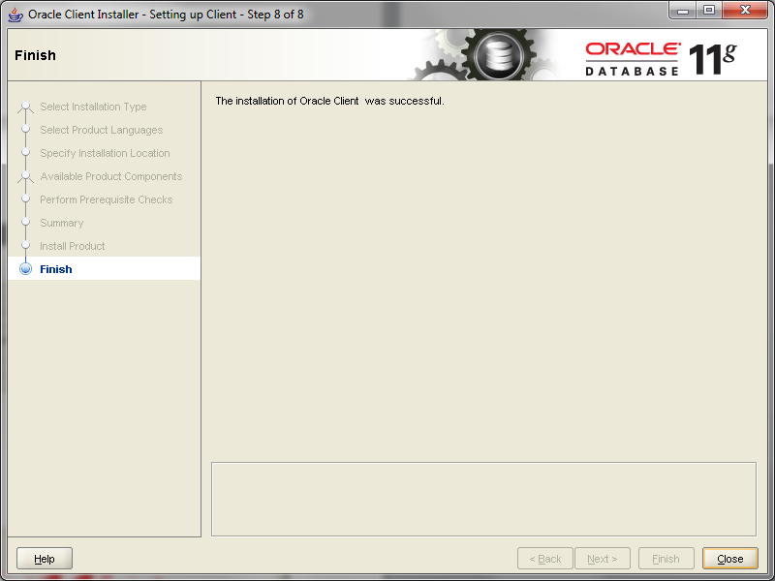

When the installation is complete, click “Close”.

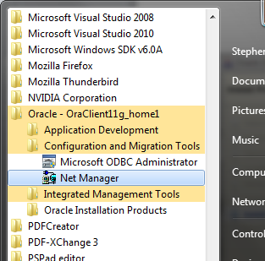

To configure TNSNAMES.ora, Run the “Net Manager” application.

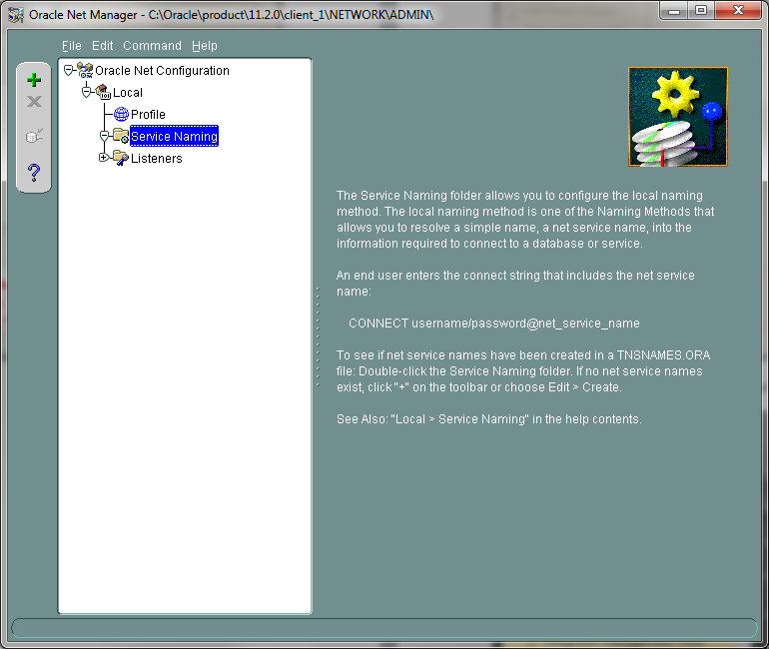

Click on “Service Naming” and click the toolbar “+” button.

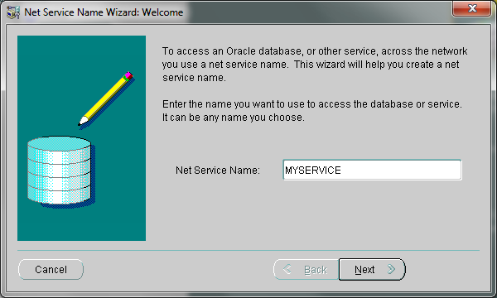

Enter the Service Name and click “Next”.

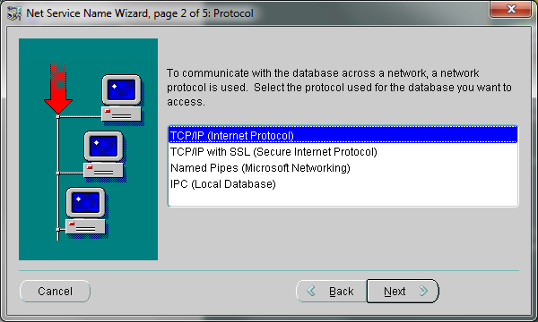

Typically, use TCP/IP. Click “Next”

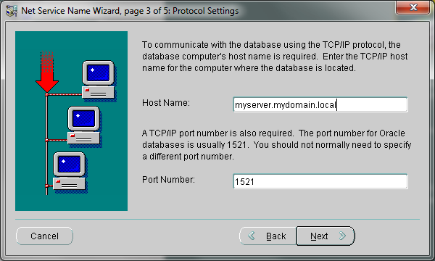

Enter the name of the oracle server. The default port for Oracle is 1521. Click “Next”.

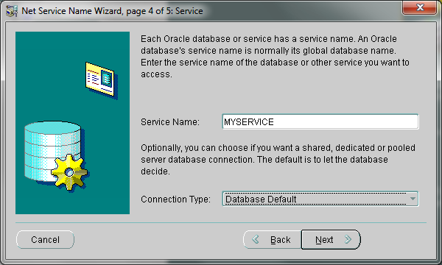

Typically, the service name is the same as the local name that you entered earlier.

Click “Next”.

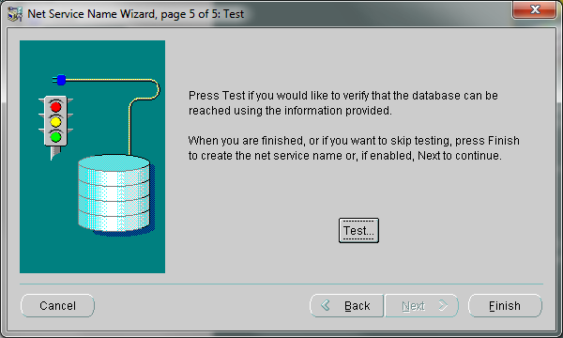

If you have credentials, you can click “Test”. If it fails, you have the option to enter different credentials.

Click “Finish”.

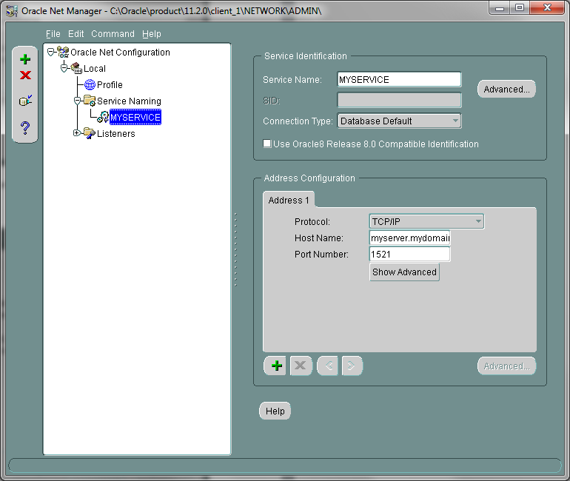

Close the Net Manager and Save the config.

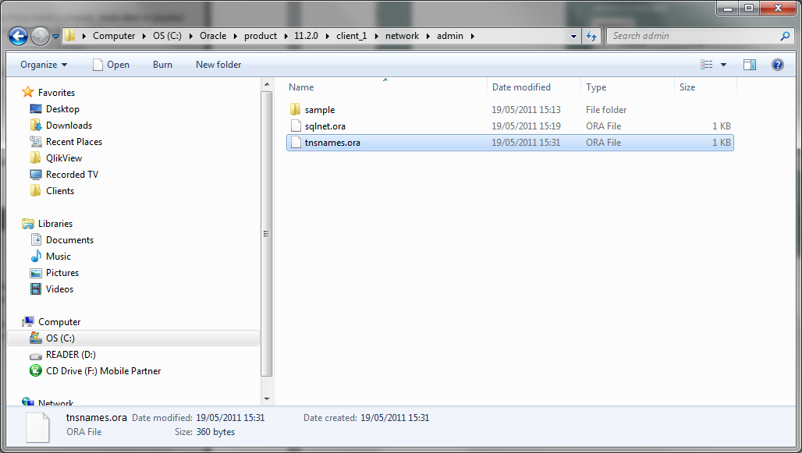

This will have setup the tnsnames.ora file.

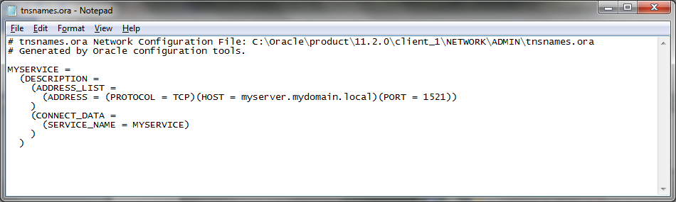

Now, you should have the Oracle provider available.

